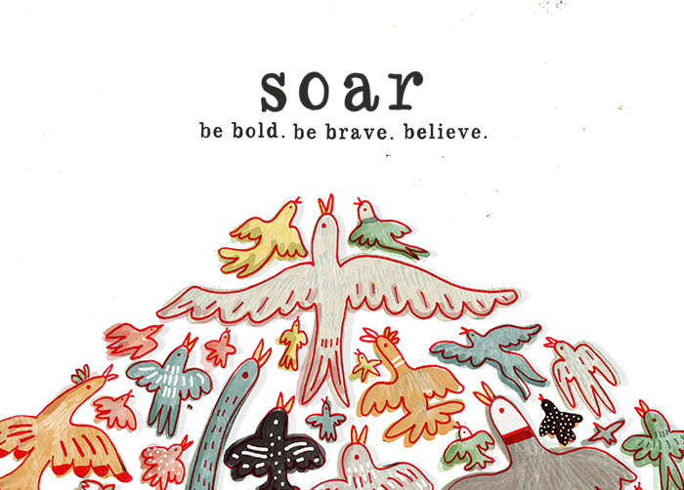

S = Strengths: What you are doing well, including your assets, capabilities, and greatest accomplishments. Don’t be afraid to recognize and celebrate your strengths.
O= Opportunities: External circumstances/changes that could improve communication, productivity, and overall workplace effectiveness and job satisfaction.
A= Aspirations: individual goals; changes you will make that will allow you to be the type of person you want to be in the workplace.
R=Results: The tangible, measurable items that will indicate when your goals and aspirations have been achieved.
- What are my strengths, what’s working well in my life, at work and at home?
- What opportunities are there for change, what isn’t working, what areas need improvement? What do I want/need to address to have a different experience in my work and life?
- What are my aspirations, what do I want to put my time and energy into when I leave here?
- What steps will I take to create results and when will I do it? (Will I enroll in a professional development course, will I take that cooking class I’ve always wanted to take, will I have that difficult conversations I’ve been putting off?). I suggest choosing 2-3 tangible and concrete goal to work towards.

